DSA ASSIGNMENT 7 Name- Vishaw Bansal
Roll no- 1024030356 

QUESTION 1
#include <iostream>
using namespace std;
void printArray(int arr[], int n) {
for (int i = 0; i < n; i++)
cout << arr[i] << " ";
cout << endl;
}
void selectionSort(int arr[], int n) {
for (int i = 0; i < n - 1; i++) {
int minIndex = i;
for (int j = i + 1; j < n; j++)
if (arr[j] < arr[minIndex])
minIndex = j;
swap(arr[i], arr[minIndex]);
}
}
void insertionSort(int arr[], int n) {
for (int i = 1; i < n; i++) {
int key = arr[i];
int j = i - 1;
while (j >= 0 && arr[j] > key) {
arr[j + 1] = arr[j];
j--;
}
arr[j + 1] = key;
}
}
void bubbleSort(int arr[], int n) {
for (int i = 0; i < n - 1; i++) {
bool swapped = false;
for (int j = 0; j < n - i - 1; j++) {
if (arr[j] > arr[j + 1]) {
swap(arr[j], arr[j + 1]);
swapped = true;
}
}
if (!swapped) break;
}
}
void merge(int arr[], int l, int mid, int r) {
int n1 = mid - l + 1;
int n2 = r - mid;
int a[n1], b[n2];
for (int i = 0; i < n1; i++) a[i] = arr[l + i];
for (int i = 0; i < n2; i++) b[i] = arr[mid + 1 + i];
int i = 0, j = 0, k = l;
while (i < n1 && j < n2) {
if (a[i] <= b[j]) arr[k++] = a[i++];
else arr[k++] = b[j++];
}
while (i < n1) arr[k++] = a[i++];
while (j < n2) arr[k++] = b[j++];
}
void mergeSort(int arr[], int l, int r) {
if (l >= r) return;
int mid = l + (r - l) / 2;
mergeSort(arr, l, mid);
mergeSort(arr, mid + 1, r);
merge(arr, l, mid, r);
}
int partition(int arr[], int l, int r) {
int pivot = arr[r];
int i = l - 1;
for (int j = l; j < r; j++) {
if (arr[j] <= pivot) {
i++;
swap(arr[i], arr[j]);
}
}
swap(arr[i + 1], arr[r]);
return i + 1;
}
void quickSort(int arr[], int l, int r) {
if (l < r) {
int pi = partition(arr, l, r);
quickSort(arr, l, pi - 1);
quickSort(arr, pi + 1, r);
}
}
int main() {
int arr[] = {64, 25, 12, 22, 11};
int n = 5;
cout << "Original Array: ";
printArray(arr, n);
selectionSort(arr, n);
// insertionSort(arr, n);
// bubbleSort(arr, n);
// mergeSort(arr, 0, n-1);
quickSort(arr, 0, n-1);
cout << "Sorted Array: ";
printArray(arr, n);
return 0;
}

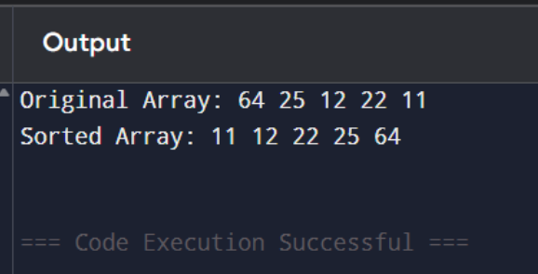

QUESTION 2
#include <iostream>
using namespace std;
void improvedSelectionSort(int arr[], int n) {
int left = 0, right = n - 1;
while (left < right) {
int minIndex = left;
int maxIndex = right;
if (arr[minIndex] > arr[maxIndex])
swap(arr[minIndex], arr[maxIndex]);
for (int i = left + 1; i < right; i++) {
if (arr[i] < arr[minIndex])
minIndex = i;
else if (arr[i] > arr[maxIndex])
maxIndex = i;
}
swap(arr[left], arr[minIndex]);
if (maxIndex == left)
maxIndex = minIndex;
swap(arr[right], arr[maxIndex]);
left++;
right--;
}
}
void printArray(int arr[], int n) {
for (int i = 0; i < n; i++)
cout << arr[i] << " ";
cout << endl;
}
int main() {
int arr[] = {64, 25, 12, 22, 11, 90, 3};
int n = sizeof(arr) / sizeof(arr[0]);
cout << "Original array: ";
printArray(arr, n);
improvedSelectionSort(arr, n);
cout << "Sorted array: ";
printArray(arr, n);
return 0;
}

